**PROJECT PART 1**

Medha Kant, 2017CS10350

For the project, a photon mapping rendering engine was made, and the scene was a Cornell box with diffuse reflective walls on 5 sides and 3 spherical balls inside the box. For this a new photon object was made and for now there is only one global photon map. There is an area light source at the top of the box which is lighting the scene.

First, photons are randomly casted from the light source and then they are stored and then their bouncing from different surface is stored. Instead of splitting the photon into two photons of smaller energy when hitting a surface, a probability-based approach was used to save space. The photons are then balanced as a K-D Tree.

For the purpose of this assignment, I took help from a pdf - “A Practical Guide to Global Illumination using Photon Mapping, Siggraph 2001, Course 38” and from the book “Realistic image synthesis using photon mapping”.

Below is a rendered image-

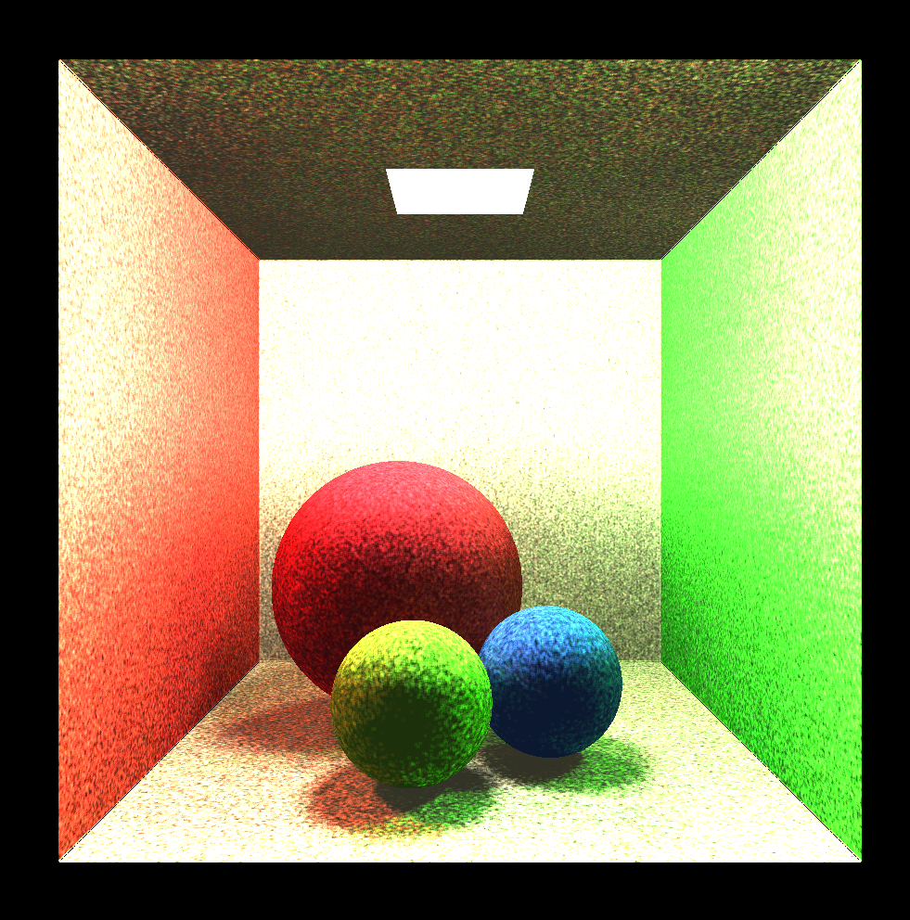

As we can see, there is color bleeding and better diffuse lighting and soft shadows. The images rendered are blurry as finite number of photons are casted in the scene.